Polytechnic University of Bucharest
Faculty of Electronics, Telecommunications, and Information Technology

A Fighting Game Between 2 Characters
Object Oriented Programming
Student: Angheluță Andrei-Alexandru
Group: 412G
2022
- Description of the program
The following program is a text-based game that simulates a battle between two characters (the “hero” and the “enemy”, respectively), each having at least one type of attack and a consumable item from which the user can choose to play. The “hero” and the “enemy” take turns in using an action (either attacking, healing, or using their consumables) and the game stops when the health bar of either character reaches the value 0. It provides an interactive experience where users can create their own characters and engage in a turn-based combat system. The program is designed to showcase the use of object-oriented programming principles, such as classes or inheritance.

- Important parts of code
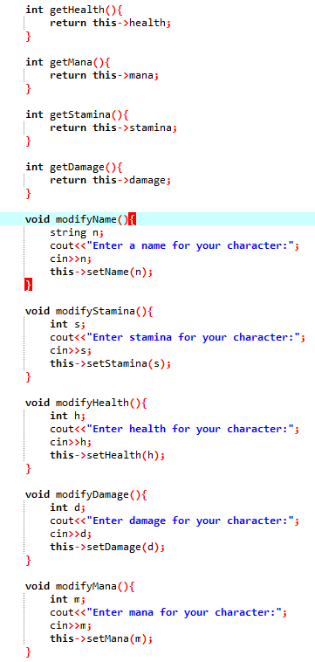
- getters for all attributes; modifiers for all attributes.
- Used libraries, virtual functions for character info and actions, setters for all attributes.

- 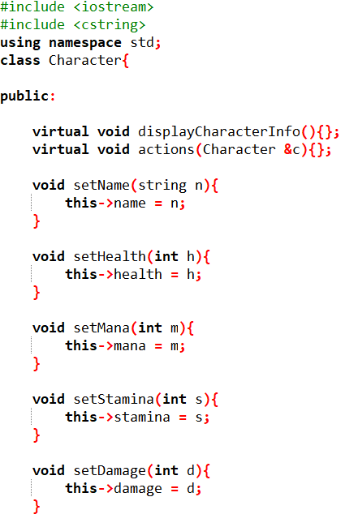

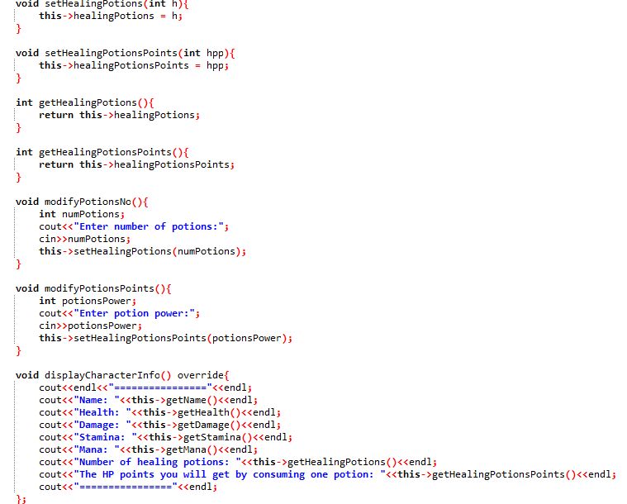
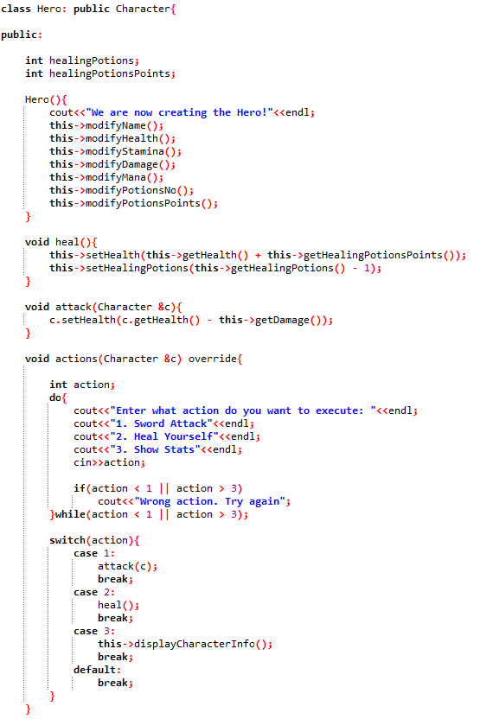
- class of first character, the “hero”.

- class of second character, the “enemy”.

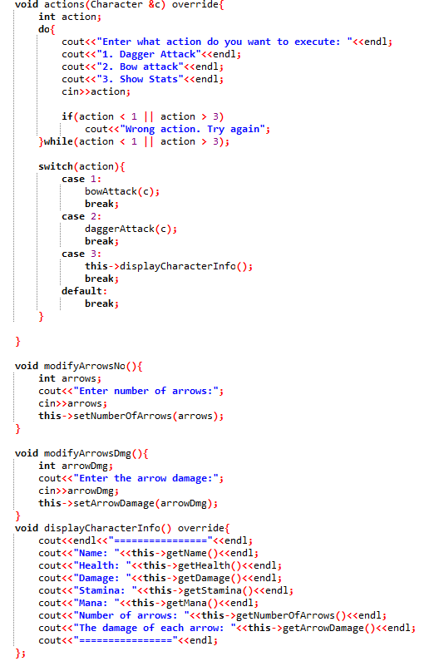
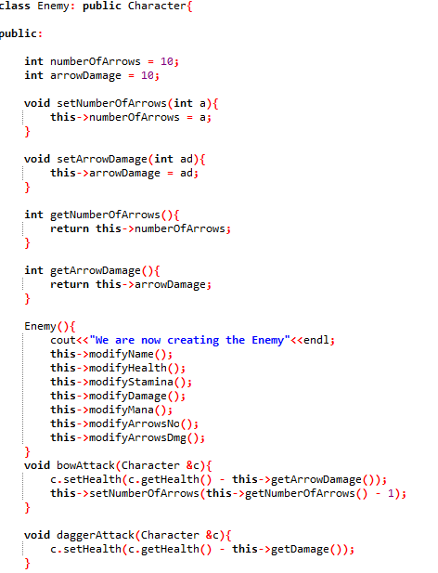

- “main” function.

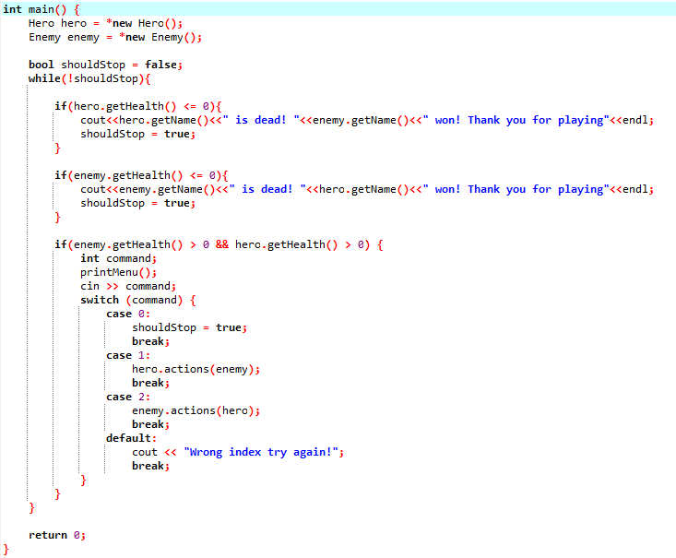

- Instances of running the program

Creating the characters

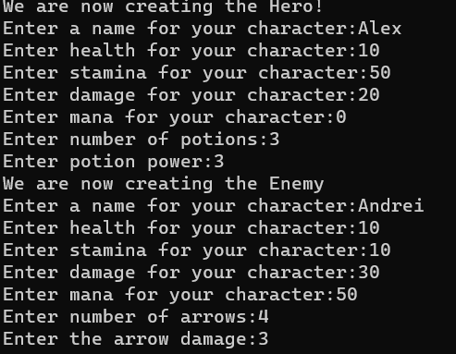
Selecting the character you want to play and the action you want to take

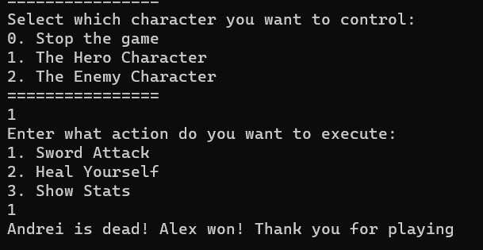

Showing the stats for the selected character

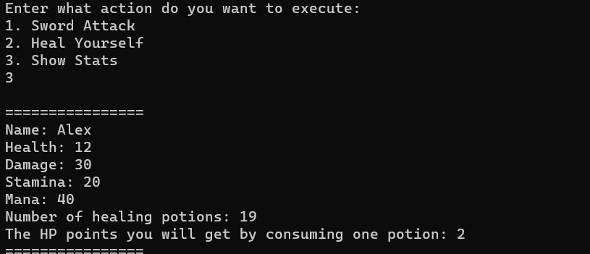

Exiting the game

